**\*\*GUIDELINES ON HOW TO PUT YOUR BRIEF TOGETHER\*\***

* Your Logo is the face of your Business for the years to come. When completing your brief, make sure choose options that are timeless and you will be happy with for atleast five years.
* Please ensure you submit your completed briefing document to your designer within **3 days** of project activation.
* Please ensure that you complete this briefing document as accurately as possible, the more in depth the brief the more we can assist you. Please ensure you do a thorough **spelling** check (if applicable).
* Please take note of the time-line for each package. These are detailed below. Your timeline starts from the date of activation.
* If you require any assistance with this document then please speak with our friendly sales consultant or your designer.
* Once a project has been activated, your Project Manager will also assist you with any queries you have during development.
* The complete scope of your product will have been detailed in quote and related invoice. This is a standard briefing document.
* **Legal compliance**. You need to follow all Copywrite laws. We cannot directly copy an image that you like. If there is a specific image that you want – please provide this as a High Resolution file created as a vector. Please also attached the ownership licence for this image which details that it can be used for commercial purposes and can be used as a Logo.
* If you have bought a website package in combination to your Logo Design package – we will activate your website development one week after your Corporate Identity package. This avoids delays with your website should your logo not be complete in time. Your logo also essentially dictates your websites colour pallet, look and feel.

•••

**STEP ONE: Your Package**

To ensure you are completing the information for the correct package – please highlight the one you purchased (this information can be found on your invoice):

|  |  |  |
| --- | --- | --- |
| LOGO DESIGN ONE: **ELEMENTAL**   * Stock based. **Black and white** logo, including one shadow (.jpg). * Up to 3 concepts, with 2 reviews. * 14 Day time-line. 4 Development hours. |  | LOGO DESIGN ONE: **CUSTOM**   * Digitally hand drawn. **Black and white** logo, including one shadow (.jpg). * Up to 3 concepts, with 2 reviews. * 14 Day time-line. 5 Development hours. |
|  |  |  |
| LOGO DESIGN THREE: **ELEMENTAL**   * Stock based. **Three colour** logo (including black & white) and one shadow (.jpg). * Up to 3 concepts, with 2 reviews. * 14 Day time-line. 4,5 Development hours. |  | LOGO DESIGN THREE: **CUSTOM**   * Digitally hand drawn. **Three colour** logo (including black & white) and one shadow (.jpg). * Up to 3 concepts, with 2 reviews. * 14 Day time-line. 5,5 Development hours. |
|  |  |  |
| LOGO DESIGN FIVE: **ELEMENTAL**   * Stock based. **Five colour** logo (including black & white) and one shadow (.jpg). * Up to 3 concepts, with 2 reviews. * 14 Day time-line. 5 Development hours. |  | LOGO DESIGN FIVE: **CUSTOM**   * Digitally hand drawn. **Five colour** logo (including black & white) and one shadow (.jpg). * Up to 3 concepts, with 2 reviews. * 14 Day time-line. 6 Development hours. |
|  |  |  |
| LOGO DESIGN SEVEN: **ELEMENTAL**   * Stock based. **Full Colour** and one shadow (.jpg). * Up to 3 concepts, with 2 reviews. * 21 Day time-line. 6,5 Development hours. |  | LOGO DESIGN SEVEN: **CUSTOM**   * Digitally hand drawn. **Full colour** and one shadow (.jpg). * Up to 3 concepts, with 2 reviews. * 21 Day time-line. 7,5 Development hours. |

Your designer will give you three options for your first review. You can then pick the elements you prefer of each, as well as the colour pallet you would prefer. From there they will create three more options for your second review, from which you will then chose the one you like.

•••

**STEP TWO: Your Business**

Please give us a little more information about your business and what you do. If your company has a Motto or Mission statement, please also include this below:

|  |  |  |
| --- | --- | --- |
| **Business Name** | : |  |
| **What your business does** | : |  |
| **What sector is your business in?** | : |  |
| **Your businesses Motto** | : |  |
| **Your businesses Mission Statement** | : |  |
| **Is your business service or product orientated?** | : |  |
| **Other Comments** | : |  |

•••

**STEP THREE: Fonts & Colour Pallets**

Have you considered your colour scheme and Look & Feel? A good reference for a **Colour Scheme** can be found at <https://colorhunt.co/>. **Font** options can be viewed at <https://fonts.google.com/>. Alternatively you can include a link to a website with the look and feel that you like.

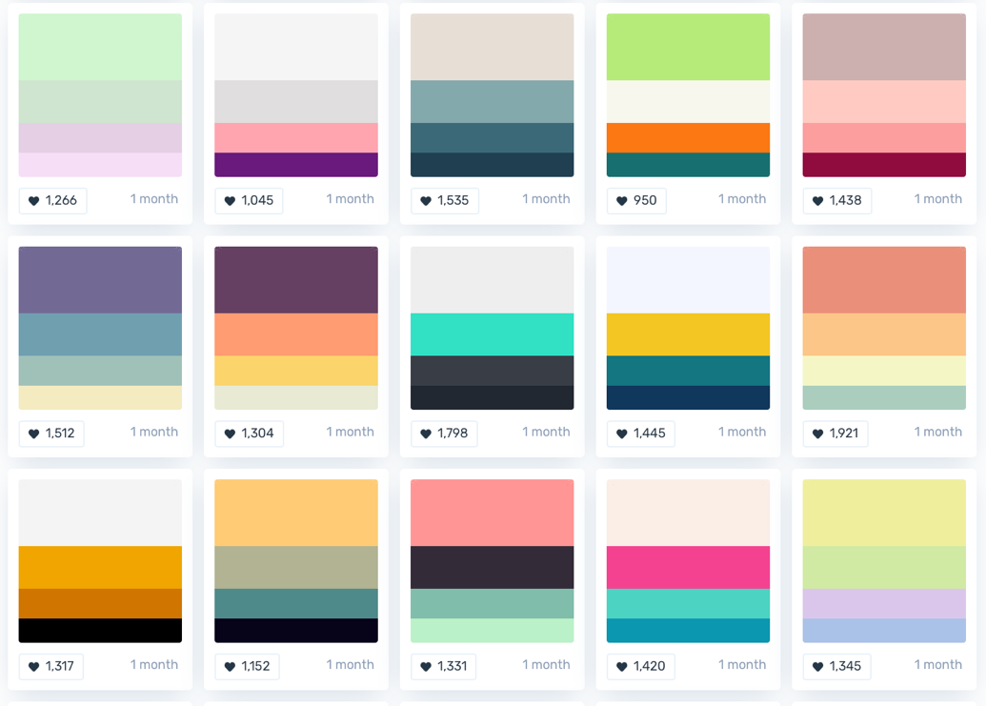

** **Examples only**

Please give us **two** colour pallet options and **three** font combinations below:

|  |  |  |
| --- | --- | --- |
| **Colour Pallet 1**  (Please remember that your colour options are dictated by the package you chose) | : | i.e. : #204051 , #3b6978 , #84a9ac , #e7dfd5  Or you can screenshot colour blocks of colour that you like.  Or a link [www.websitedesign.co.za](http://www.websitedesign.co.za) |
| **Colour Pallet 2**  (Please remember that your colour options are dictated by the package you chose) | : |  |
| **Font 1**  (Maximum 2 per combination) | : | i.e. : Courier & Dosis  Or a link [www.websitedesign.co.za](http://www.websitedesign.co.za) |
| **Font 2**  (Maximum 2 per combination) | : |  |
| **Font 3**  (Maximum 2 per combination) | : |  |

•••

**STEP FOUR: Your Logo**

Do you want a **Graphic** based logo, or a **Text** based logo? Are there any specific types of images you would like to appear in your logo? Below are examples of each.

|  |  |  |
| --- | --- | --- |
| **Text** based Logo |  | **Graphic** based Logo |
|  |  |  |

Please include these options below:

|  |  |  |
| --- | --- | --- |
| **Option 1**  (Please remember that we cannot copy images) | : | i.e. : Text based |
| **Option 2**  (Please remember that we cannot copy images) | : |  |
| **Option 3**  (Please remember that we cannot copy images) | : |  |
| **Example Image 1**  (Please remember that we cannot copy images) | : | i.e. : |
| **Example Image 1**  (Please remember that we cannot copy images) | : |  |

•••

**CONGRATULATIONS!**

If you have completed all of the above steps, then we have what we need in order to design a first preview of your new Logo. To proceed, please send this document back to your sales consultant.

**We look forward to creating the face of your Business.**

•••

Disclaimer.

Websitedesign.co.za attempts to ensure the information within this document is correct at the time of publication. It reserves the right to update this document without written notice.